H1:
Recycling symbols on product packaging will help you sort waste correctly

Exc.
Learn how to recycle, understand recycling symbols!

Perex:
Being able to evaluate and use information has always been important. In the past this was a question of survival, later on advanced civilizations started using symbols to communicate information, and even after writing was invented symbols have continued to play an important role in our lives. Everybody knows the meaning (symbol) of the apple logo with a bite in it, radioactivity, the dollar, and the switch on/off button. Also the world of waste sorting and recycling is full of symbols – do you know what the green dot and the triangle with arrows mean? This article by Samosebou.cz will provide important information regarding recycling symbols on product packaging.

Waste sorting is the first step without which waste recycling would be impossible. In order to be able to repurpose sorted waste in the manufacturing of new products, waste must be sorted correctly.

Product packaging is very important – it plays an essential role in many ways. It has an influence on customers’ purchase decisions, it allows for the products to be transported, it provides information about the producer, the product’s composition, and also the so-called recycling signs are displayed on it.

Packaging requirements, including the symbols, are regulated by laws and directives that apply in the Czech Republic and also internationally.

Some recycling symbols are not compulsory and have a general meaning, others inform us about the material composition of the packaging or have a specific purpose.

The legislation in place does not specify the duty to inform about the way packaging should be handled; this duty applies only to packaging listed in laws on waste, chemical substances and drugs.
Therefore it may happen that you will not find information on a yogurt cup about the material that it is made of or what to do with it after you have eaten the yogurt. It is for the producers to decide what information to provide.

Recycling symbols – a guide to the correct handling of packaging waste
Do you know what the so-called green dot or the man throwing trash into dust bin mean? Don’t worry if you don’t, Samosebou.cz will give you the right answers!

The “green dot” recycling sign
You may have noticed a round symbol with two arrows inside on packaging. This trademark is used on product packaging for which a deposit refund system exists to collect and reuse the packaging material.

The crossed-out wheeled bin symbol
This recycling sign means that the packaging material shall not be put in recycling bins or in municipal solid waste containers (rubbish bins, dust bins), but that it is intended for ecological disposal. Such packaging material should be taken to the seller (collection points), or to a scrap yard.

The “man throwing trash into dust bin” symbol
This is a voluntary sign that producers can use on packaging to encourage consumers not to litter the environment and throw waste to a bin (depending on other symbols, these could be the colour-coded bins for recycling of the given type of waste, municipal solid waste bins, etc.).

The recycling signs below are used to provide more detailed information on the material composition of the waste. The triangle label is accompanied by a description or a code or a combination of the two to identify the material.

What does the triangle with full arrows mean?
If you see this symbol on product packaging, you should definitely take it to a colour-coded recycling bin as it identifies which specific packaging material it was made from. Thanks to this, it can be taken directly for recycling and the secondary raw material will be used to make new products.

What to do with packaging that has a silhouette arrows triangle on it?
Recycled material (i.e. a secondary raw material) was used to produce this packaging. Also this packaging should be thrown into the appropriate recycling bin.

Thanks to the sorting of packaging material, a recycled PET bottle can be made into another PET bottle that are then used to make textile, which can be used to make, for example, fleece jackets, sleeping bag fillers, curtains, nappies, and many other useful things.
Sorted glass can be recycled forever, so a broken vase can be made into a new glass, which in turn can be made into a window pane which then can be made into a wine bottle.

Are you not sure which packaging materials to sort?

The infographic below gives a brief overview of the basic types of materials used for the production of packaging, and their recycling signs.
Packaging that has codes or letters given in the infographic shall be sorted in the appropriate recycling bins – this will ensure that they will be recycled.

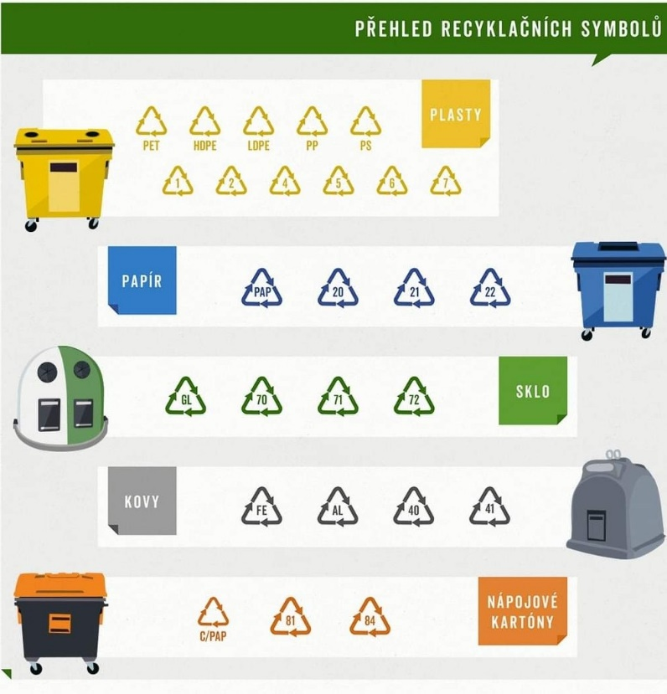
Description: An infographic with an overview of recycling symbols can help sort out waste correctly.

The sorted waste can be made into new products; this helps us preserve natural resources and the nature. Extracted and processed materials can be put back into circulation in the same or changed form.

Another important precondition for waste recycling is following the rules for correct sorting of waste, which includes:
- making the recyclables smaller (by crushing, crumpling, flattening, etc.) – this saves space for more waste;
- avoiding putting dirty or oily waste in recycling bins;
- sorting in accordance with the information on the sticker placed on the given recycling bin (recycling rules may differ in different towns and villages), etc.

For more information on sorting rules, read this article on How to sort different types of waste correctly.

Other useful information on waste sorting in the Czech Republic:
- a flier – a guide in pictures to how to sort waste (A5)
- a poster – a guide in pictures to how to sort waste (A3).

It makes sense, sort waste, the nature will reward you!

FB
Do you know what the recycling sign with the man throwing trash into dust bin means or what the silhouette arrows triangle tells us? To get more valuable help, read this article on Samosebou.cz!

